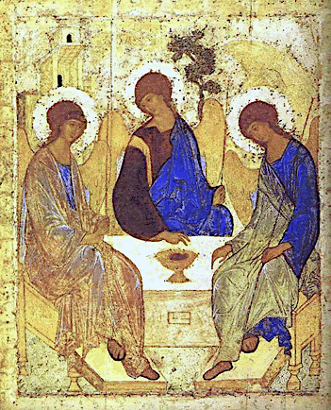

TRINITY SUNDAY
May 30, 2021

Reading I: Deuteronomy 4:32-34, 39-40
Responsorial Psalm 33:4-5, 6, 9, 18-19, 20, 22
Reading II: Romans 8: 14-17
Gospel: Matthew 28:16-20

Trinity, Andrei Rublev 1410

REFLECTION QUESTIONS

Reading I: Deuteronomy 4:32-34, 39-40 (Did Anything So Great Ever Happen Before?)
Moses could not imagine anything as great as God’s love for God’s people. What do you find hard to imagine about God’s love for you?

Reading II: Romans 8: 14-17 (We are Children of God)
Do you think of yourself as having an intimate relationship with God? Why? Why not?

Gospel: Matthew 28:16-20 (Make Disciples of All Nations)
Jesus commissions the apostles to make disciples of all nations. How do you make disciples?

Adapted from Breaking Open the Lectionary, Cycle A, Margaret Nutting Ralph, Paulist Press, 2007, and from Praying Towards Sunday: Trinity Sunday B, Anne Osdieck, The Sunday Website at St. Louis University, https://liturgy.slu.edu/TrinityB053021/reflections_osdieck.html.

PRAYER

In the name of the Father (who gave us his only child), and of the Son (who gives us himself, revealing eternal Love for us), and of the Holy Spirit (our constant companion now and always): “We can only stand in awe-struck silence before such love that is beyond boldest expectation, beyond all telling”. Amen.

Adapted from Praying Towards Sunday: Trinity Sunday B, Anne Osdieck, The Sunday Website at St. Louis University,
https://liturgy.slu.edu/TrinityB053021/prayerpathmain.html.

