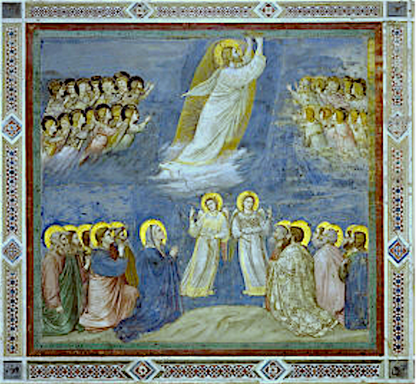

SOLEMNITY OF THE
ASCENTION OF THE LORD B
May 16, 2021
Reading I: Acts 1:1-11
Responsorial Psalm: 47:2-3, 6-7, 8-9
Reading II: Ephesians 1:17-23
Gospel: Mark 16:15-20

The Ascension of Our Lord

REFLECTION QUESTIONS

Reading I: Acts 1:1-11 (You will be by Witnesses)
Are you a Christian witness? Explain.

Reading II: Ephesians 1:17-23 (Christ at [God’s] right hand far above every principality, authority, power, and dominion)
Do you experience the power of the Risen Lord in your life? Explain.

Gospel: Mark 16:15-20 (Go into the Whole World)
How do you personally carry on the mission of Jesus?

Adapted from Breaking Open the Lectionary, Cycle A, Margaret Nutting Ralph, Paulist Press, 2007 and from
The Sunday Website at St. Louis University, Discussion Questions: Ascension of the Lord B, Anne Osdieck, https://liturgy.slu.edu/AscensionB051621/reflections_osdieck.html.

PRAYER

Jesus, put your Gospel in our hearts. Put it within our minds and souls too. Let us take your Word to every living creature, in daylight and in the dark of night, from housetops, pulpits, and within every town. Consecrate us in your truth. As you are one in love with the Father and the Spirit, make us one in your love. Amen.

Adapted from The Sunday Website at St. Louis University, Praying Toward Sunday: Ascension of the Lord B, Anne Osdieck, https://liturgy.slu.edu/AscensionB051621/prayerpathmain.html.

Art Source: Giotto, Scrovegni Chapel, Padua, Italy, 1305.

