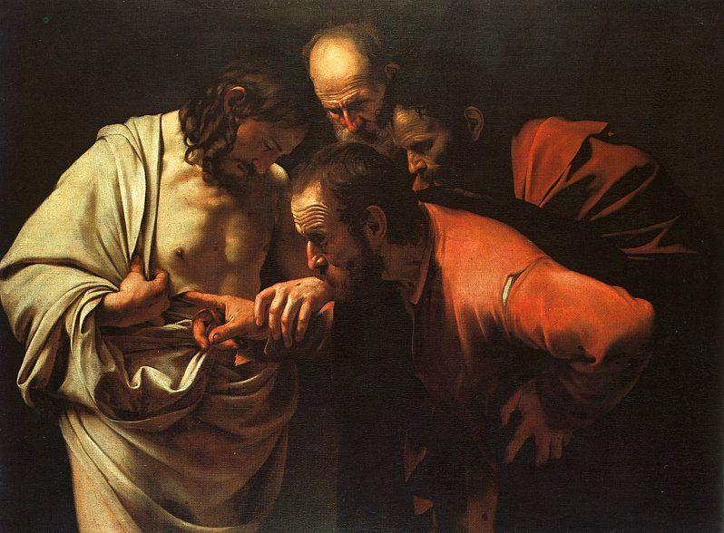

SECOND SUNDAY OF
EASTER B

Reading I: Acts 4:32-35
Responsorial Psalm 118:2-4, 13-15, 22-24
Reading II: 1 John 5:1-6
Gospel: John 20:19-31

Incredulity of St. Thomas by Caravaggio

REFLECTION QUESTIONS

Reading I: Acts 4:32-25 (They Shared Everything in Common)
Do you share what you have with those in need? Why? Why not?

Reading II: 1 John 5:1-6 (We Love the Children of God When We Love God and Keep His Commandments)
Does your love of God make a difference in the way you treat others? Explain.

Gospel: John 20:19-31 (Risen Jesus Said to the Disciples ”Peace Be with You”)
Has being a Christian added to your peace of mind? Explain.

Adapted from The Sunday Website at St. Louis University: Spiritual Reflections, Discussion Questions, Easter Sunday B, Anne M. Osdieck, https://liturgy.slu.edu/Triduum2021B/reflections_osdieck.html.

PRAYER

Risen Lord Jesus, when you appeared to your disciples in the upper room, you breathed on them and gave them your own Spirit. Fill us with your very own life so we can take your love and forgiveness to every single person on earth. Amen.

Adapted from The Sunday Website at St. Louis University: Praying Toward Sunday, Second Sunday of Easter B, Anne M. Osdieck, https://liturgy.slu.edu/2EasterB041121/prayerpathmain.html.

Art Source: Incredulity of St. Thomas by Caravaggio: http://www.christusrex.org/www2/art/images/carav10.jpg, Public Domain, https://commons.wikimedia.org/w/index.php?curid=6804893

