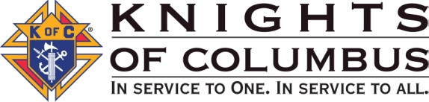
Council Meeting Message, March 2021

This month marks one year under COVID-19 restrictions. I remember when the news of shutting the Supreme Office was announced. I, like many I think, thought this would last a couple of months and all of us would get back to normal. The reality is much different. Maybe some of you are working from home…maybe some will be working from home for the foreseeable future. I realize this has not been easy for many of you. When it began, I wondered how I would be able to help my brother Knights. But as restrictions were put in place, we were provided with a new way to meet with members virtually on our computers and we were given a number of tools to ensure that you, our members and your families, were served.
Using these new tools, I have found that I am more efficient. I save travel time and can have more meetings in a day. I’ve found that many of you like the idea of meeting virtually. It’s less stress for you to simply sit down in front of your computer, click on a few buttons and we can have a confidential conversation about your needs, wants and desires. For service issues I can meet much more quickly and have all the forms I might need to help you right at my fingertips…No more running out to the car to get a form only to find out my paper file is depleted.
We’ve had our e-Application process for a while, and with pandemic restrictions members have found it very valuable to be able to sign electronically when we meet virtually.
It’s been a very different year: We missed much of the solemnity of Holy Week and Easter with many of us either social distancing at church or live-streaming Mass; by summer we were able to get outside as long as we didn’t get too close to others who were out. Vacations were pretty much out of the question—I know I had a “stay-cation” with my family. By fall we had figured out how to deliver candy from a socially acceptable distance to those few trick or treaters who braved the night. Thanksgiving traditions of large family gatherings were taboo, and Christmas was so much smaller in 2020. Joyously we experienced the beatification of Blessed Michael McGivney.
Now we’ve come full circle into 2021. The vaccine is on the way. Some of you have already received it. Looks like light at the end of the tunnel; but we still have to be vigilant, still have to protect each other.
I am most thankful to all of you. Many of you met with me this year and wanted to make sure your desire for financial security was up to date. It was my pleasure to take the time to analyze your situation and give you my recommendations. I look forward to meeting with many more of your in the months ahead whether virtually or face to face. Please contact me if you have any questions; I am here to serve you, my members, and your families.
I pray you will be safe and healthy.
Vivat Jesus!

