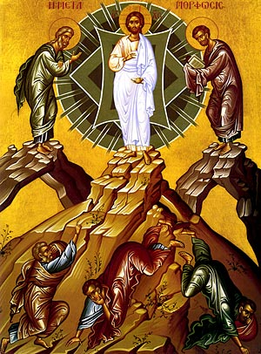

SECOND SUNDAY OF LENT B
February 28, 2021
Reading I: Genesis 22:1-2, 9a, 10-13, 15-18
Responsorial Psalm 116:10, 15, 16-17, 18-19
Reading II: Romans 8:31b-34
Gospel: Mark 9:2-10

Transfiguration of Jesus Icon

REFLECTION QUESTIONS

Reading I: Genesis 22:1-2, 9a, 10-13, 15-18 (Sacrifice of Isaac)
How much do you trust in God? Explain.

Reading II: Romans 8: 31b-34 (God is for Us)
Do you believe God is for us? For you? Explain.

Gospel: Mark 9:2-10 (Transfiguration of Jesus)
How do you experience here and now the glory of Jesus?

Adapted from The Sunday Website at St. Louis University: Spiritual Reflections, Discussion Questions, First Sunday of Lent B, Anne M. Osdieck, https://liturgy.slu.edu/1LentB022121/reflections_osdieck.html.

PRAYER

Father, all powerful and ever living God, we do well always and everywhere to give you thanks through Jesus Christ our Lord. On your holy mountain he revealed himself in glory in the presence of his disciples. He had already prepared them for his approaching death. He wanted to teach them through the Law and the Prophets that the promised Christ had to first suffer and so come to the glory of his resurrection. In our unending joy we echo on earth the song of the angels in heaven as they praise your glory forever. Amen.

Second Sunday of Lent, “Transfiguration” (preface 13), The Sacramentary as cited in Word and Worship Workbook for Year B, Mary Birmingham, Paulist Press, 2000.

