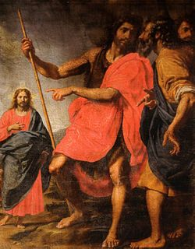

SECOND SUNDAY
ORDINARY TIME B
January 17, 2021

Reading I: 1 Samuel 3:3b-10, 19
Responsorial Psalm 40:2, 4, 7-8, 8-9, 10
Reading II: 1 Corinthians 6:13c-15a, 17-20
Gospel: John 1:35-42

Saint John Pointing Saint Andrew to Jesus the Messiah
Ottavio Vannini, 17th Century

REFLECTION QUESTIONS

Reading I: 1 Samuel 3:3b-10, 19 Call of Samuel
Who in your life has helped you listen to God’s call? How?

Reading II: 1 Corinthians 6:13c-15a, 17-20 Your Body is a Temple of the Holy Spirit
How do you respect your body? Others’ bodies? Explain.

Gospel: John 1:35-42 What Are You Looking For?
Jesus asked the disciples, What are you looking for? What are you looking for?

Adapted from Breaking Open the Lectionary, Cycle A, Margaret Nutting Ralph, Paulist Press, 2007.

PRAYER

Almighty and ever-present God, your watchful care reaches from end to end and orders all things in such power that even the tensions and the tragedies of sin cannot frustrate your loving plans. Help us to embrace your will, give us the strength to follow your call, so that your truth may live in our hearts and reflect peace to those who believe in your love. We ask this in the name of Jesus the Lord. Amen.

Adapted from Second Sunday in Ordinary Time: “Alternative Opening Prayer,” The Sacramentary.
Printed in Word and Worship Workbook for Year B, Mary Birmingham (Mahweh, New Jersey: Paulist Press, 2000).

