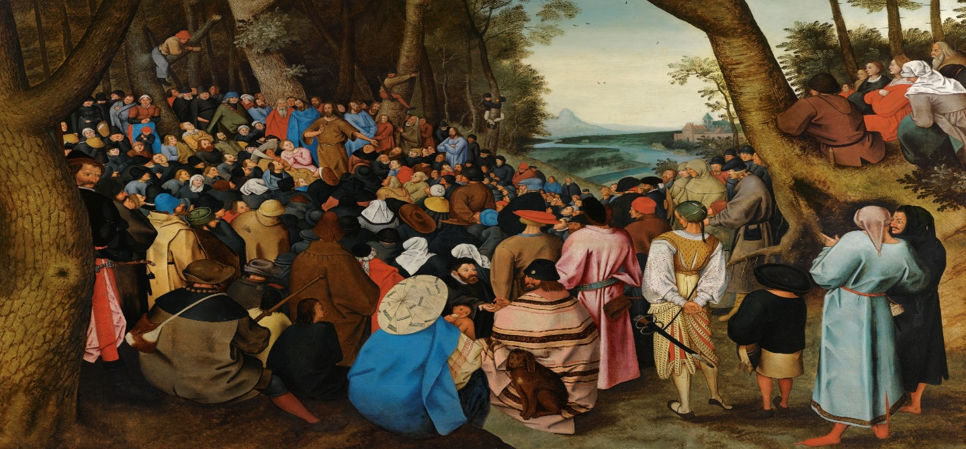
St. John the Baptist Preaching to the Masses in the Wilderness by Pieter Breughel the Younger, 1564-1638

SECOND SUNDAY OF ADVENT B
December 6, 2020
Reading I: Isaiah 40:1-5, 9-11
Responsorial Psalm: 85:9-10, 11-12, 13-14
Reading II: 2 Peter 3:8-14
Gospel: Mark 1:1-8
REFLECTION QUESTIONS
Reading I: Isaiah 40:1-5, 9-11 (Give Comfort to My People)
What can you do to smooth the “rough spots” in the lives of the
people around you?

Reading II: 2 Peter 3:8-14 (Lord is Patient with Us)
How is God patient with you? How are you patient with yourself? Others?

Gospel: Mark 1:1-8 (Prepare the Way of the Lord)
How do you share in the mission of John the Baptist to proclaim Christ’s coming into the world today?
Adapted from Praying Towards Sunday: Second Sunday in Advent B, Anne Osdieck, The Sunday Website at St. Louis University, https://liturgy.slu.edu/2AdvB120620/reflections_osdieck.html.

PRAYER
We ache in holy hunger waiting for you. Come to us all, Lord Jesus. Turn our crooked roads into smooth paths. Send gentle rain and teeming harvests of justice and healing. Make all well, and make each and every one a channel of your peace. Amen.
Adapted from Praying Towards Sunday: Second Sunday of Advent B, Anne Osdieck, The Sunday Website at St. Louis University, https://liturgy.slu.edu/2AdvB120620/prayerpathmain.html.

