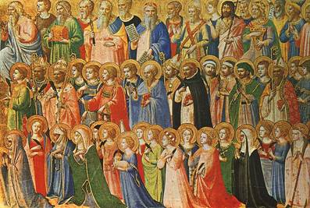
SOLEMNITY OF ALL SAINTS
November 1, 2020

Reading I: Revelation 7:2-4, 9-14
Responsorial Psalm 24:1bc-2, 3-4ab, 5-6
Reading II: 1 John 3:1-3
Gospel: Matthew 5:1-12a

REFLECTION QUESTIONS

Reading I: Revelation 7:2-4, 9-14 Faithfulness to God in Difficult Times
How do you deal with the indifference and resistance to the values of Christianity you encounter in your life?

Reading II: 1 John 3:1-3 God’s Beloved
Whom do you know that you consider to be a saint? Why do you think of this person in this way?

Gospel: Matthew 5: 1-12a Beatitudes
Do you perceive yourself as blessed as Jesus teaches in the Beatitudes? Why? Why not?

Adapted from Breaking Open the Lectionary, Cycle A, Margaret Nutting Ralph, Paulist Press, 2007, and from The Sunday Website at St. Louis University, Discussion Questions, Solemnity of All Saints, Anne Osdieck, https://liturgy.slu.edu/AllSaints2020/reflections_osdieck.html.

PRAYER

God, all powerful and ever-living God, today we rejoice in the holy men and woman of every time and place. May their prayers bring us your forgiveness and love. We ask this through our Lord Jesus Christ, your Son, who lives and reigns with you and the Holy Spirit, one God for ever and ever. Amen.

Adapted from Solemnity of All Saints: Opening Prayer, The Sacramentary.

